|  |  |
| --- | --- |
| **Ex. No. 1** | **Design a Web Page using HTML** |
| **Date of Exercise** | 18/07/2022 |
| **Web Host Link** |  |
| **Youtube Link** | https://youtu.be/WLxvdcKuHZQ |

**Aim**

Create a HTML web page for your Personal Profile that conforms to HTML features and has the following elements: doctype, html, meta (in the revised html5 format), title, head, body, div, p, headings, image, anchor, table, list, html comment

**Description**

* **<head>** Defines information about the document
* **<title>** Defines the title of a document
* **<body>** The tag defines the document's body
* **<div>** Thetag defines a division or a section in an HTML document.
* **<p>** The Paragraph element. The <p> HTML element **represents a paragraph.**
* **<h>** HTML defines six levels of headings. A heading element implies all the font changes, paragraph breaks before and after, and any white space necessary to render the heading. The heading elements are H1, H2, H3, H4, H5, and H6 with H1 being the highest (or most important) level and H6 the least.
* **<img>** The tag is used to embed an image in a web page
* **<a href>** An anchor is a piece of text which marks the beginning and/or the end of a hypertext link
* **<table>** An HTML table consists of one <table> element and one or more <tr>, <th>, and <td> elements
* **<li>**

**Description List** or Definition List displays elements in definition form like in dictionary. The <dl>, <dt> and <dd> tags are used to define description list.

The 3 HTML description list tags are given below:

1. **<dl> tag** defines the description list.
2. **<dt> tag** defines data term.
3. **<dd> tag** defines data definition (description).

**Program**

<!DOCTYPE html>

<html>

    <head>

        <meta charset="UTF-8" />

        <title>

            Exp 1

        </title>

    </head>

    <body>

        <div id="resume" align="center">

            <br>

            <b><h2>My Resume</h2></b>

            <br>

        </div>

        <div id="intro">

            <table cellspacing="50" border = "0" width="1200">

                <tr>

                    <td style="text-align: left">Manju S<br>URK20CS2054<br>CSE - AI<br>Ph:9025583711<br>Email:manjus20@karunya.edu.in</td>

                    <td style="text-align: right">

                        <img src = "C:\Users\DELL\Pictures\New folder (2)\DSC_0667.jpeg" width="15%" height="15%" alt="Image not found." align="right">

                    </td>

                </tr>

            </table>

        </div>

        <div>

            <a target="_blank" href="http://www.karunya.edu">My college </a>

            <a target="_blank" href="D:\WebTech\email.html">Email</a>

            <a target="_blank" href="D:\WebTech\contact.html">Contact me</a>

            <a target="_blank" href="D:\WebTech\Assign_1.html">Visit my Website</a>

            <a target="_blank" href="">

            <img src="https://tse1.mm.bing.net/th?id=OIP.Ua5AXhtGRgPuisZVmetclQHaFL&pid=Api&P=0&w=248&h=173"

            alt="Image not found." height="8%" width="5%">

            </a>

            <a target="_blank" href="">

            <img src="https://blog.oxfordcollegeofmarketing.com/wp-content/uploads/2015/03/linkedin.jpg"

            alt="Image not found." height="9%" width="6%">

            </a>

        </div>

        <div id="objective">

            <br><br>

            <b>Career Objective</b><br>

            A Career Objective or a Resume is essentially a heading statement that describes your professional goals in two or three sentences.<br>

            Employers looking to hire an employee for a position tend to seek candidates that are driven enough to understand what they want.

        </div>

        <div id="marks_table">

            <br><br>

            <b>Academic Details</b>

            <table border="1" cellspacing="0" cellpadding="4">

                <tr>

                    <th></th>

                    <th>School / College</th>

                    <th>Board / University</th>

                    <th>Percentage of Marks</th>

                    <th>Year of Passing</th>

                </tr>

                <tr>

                    <th>B.Tech</th>

                    <td>College</td>

                    <td>University</td>

                    <td>80%</td>

                    <td>2024</td>

                </tr>

                <tr>

                    <th>HSC</th>

                    <td>School</td>

                    <td>Board</td>

                    <td>88.2%</td>

                    <td>2020</td>

                </tr>

                <tr>

                    <th>SSLC</th>

                    <td>School</td>

                    <td>Board</td>

                    <td>70%</td>

                    <td>2018</td>

                </tr>

            </table>

        </div>

        <div id="technical">

            <br><br>

            <b>Technical skills</b>

            <ol>

                <li>Data Structures</li>

                <li>Web development</li>

                <li>Python programming</li>

                <li>Java programming</li>

                <li>Android apps development</li>

            </ol>

            <br><br>

            <b>Advanced Technology skills</b>

            <ul>

                <li>Data Science</li>

                <li>Data Analysis</li>

                <li>Machine Learning</li>

            </ul>

        </div>

        <div id="internship">

            <br><br>

            <b>Internship completed</b><br>

            Samsung App development

        </div>

        <div id="gallery">

            <br><br>

            <b>Photo Gallery</b>

            <br><br>

            &emsp;&emsp;&emsp;&emsp;

            <img src="C:\Users\DELL\Pictures\New folder (2)\download.jpg"

            alt="Image not found." height="30%" width="30%">

        </div>

        <br><br>

        <a align="right" href="#"> Back to Top </a>

        <a align="right" href="#gallery"> Gallery </a>

        <a align="right" href="#internship"> Internship </a>

        <a align="right" href="#technical"> Technical </a>

        <a align="right" href="#marks_table"> Marks Table </a>

        <a align="right" href="#objective"> Objective </a>

        <a align="right" href="#intro"> Introduction </a>

        <br><br>

    </body>

</html>

**Output**

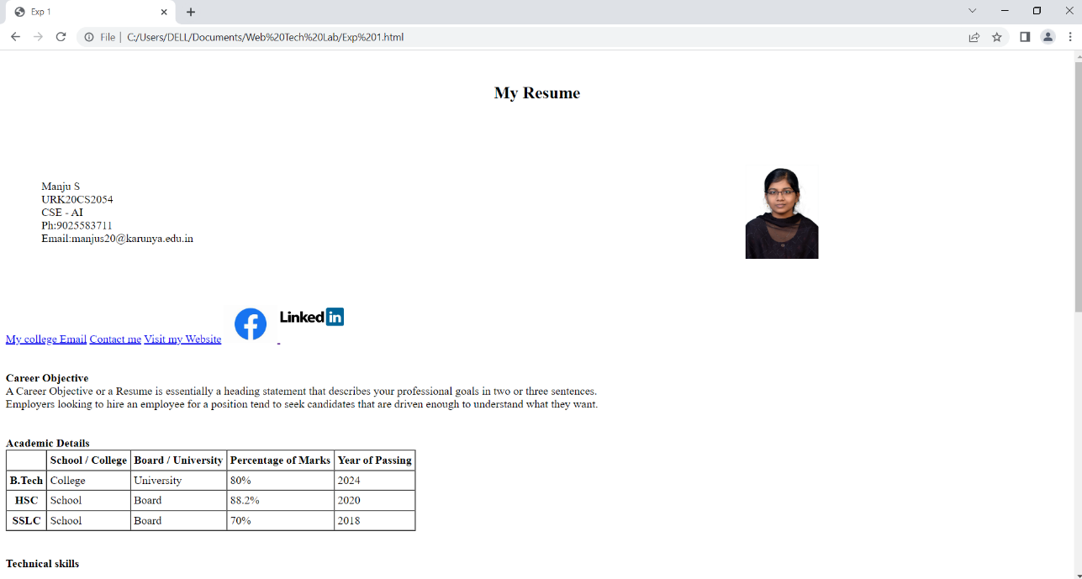

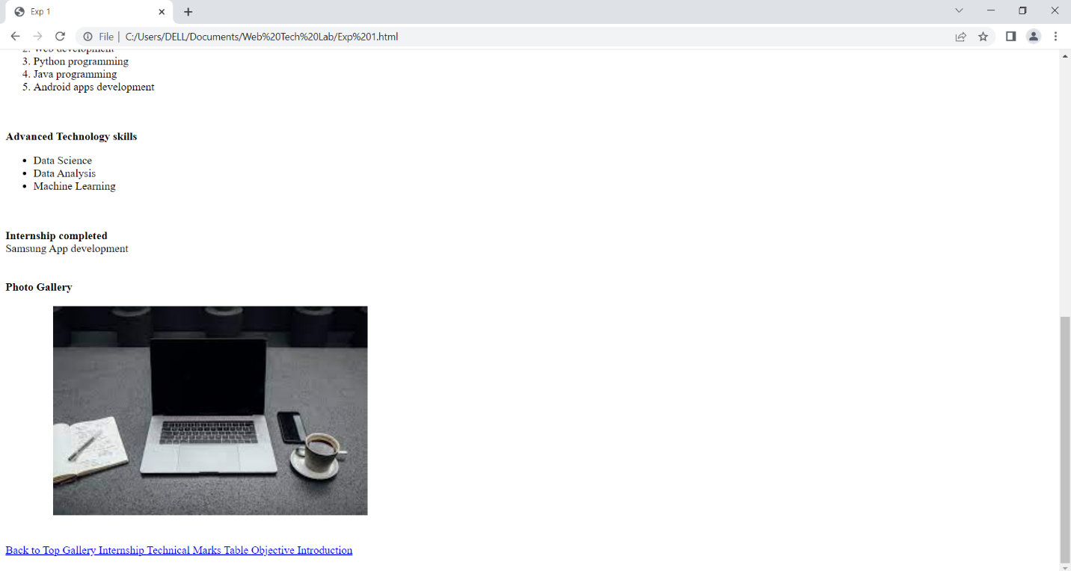

**Result**

Thus a HTML web page for Personal Profile that conforms to HTML features is coded, compiled and executed successfully.